Welcome to Mrs. Hamblin’s
6th Grade Science Class 19/20
Beer Middle School Home ⃒
Text Book @www.hmhco.com/one/login/?
Lessons are subject to change

Week of  Mar4- 8, 2020 | Update on lessons
Monday  May 4- 8 | Warm up:  I am currently posting all lessons on Schoology. Many of you are already submitting lessons to me there or by emails. I am trying to get back to you in a timely manner.  It has been so nice to hear from you and I love the pictures some of you have sent, Kadance and Thank. Made me smile. This has been difficult on all of us, especially you students and your families. I think of you and say a prayer for you.  We are starting lessons in the Ecology workbook. So you will be able to access it by going online to HMH website. I will include a link there.  I appreciate your patience with me as this too is a new experience for me. Take care and enjoy the upcoming warm weather over the weekend.  Take care and be well!

Week of  March 16-20, 2020 | Lesson
Monday  Mar. 9 | Warm up:  Unit Test: Plate tectonics  See test below. Complete it and save!
Tuesday  Mar. 10 | Warm up:  Intro to energy unit  Bill Nye video  - Warm up March 17, 2020  Q: Where does energy come from?  - Take attendance.  - We are starting a new unit on energy.  - You tube “Bill Nye Energy” https://m.youtube.com/watch?v=8qmSzMwTkpk&t=10s  - Students take notes in science notebook  - Discuss the video afterwards.  If time allows you may watch “Forms of Energy” ( 12:  https://www.youtube.com/watch?v=DvCWuOuaG_c
Wednesday  Mar. 11 | Warm up:  Energy  Brain pop Types of energy Watch videos  Free access for now.
Thursday  Mar. 12 | Warm up:

Friday  Mar. 13 | Warm up:

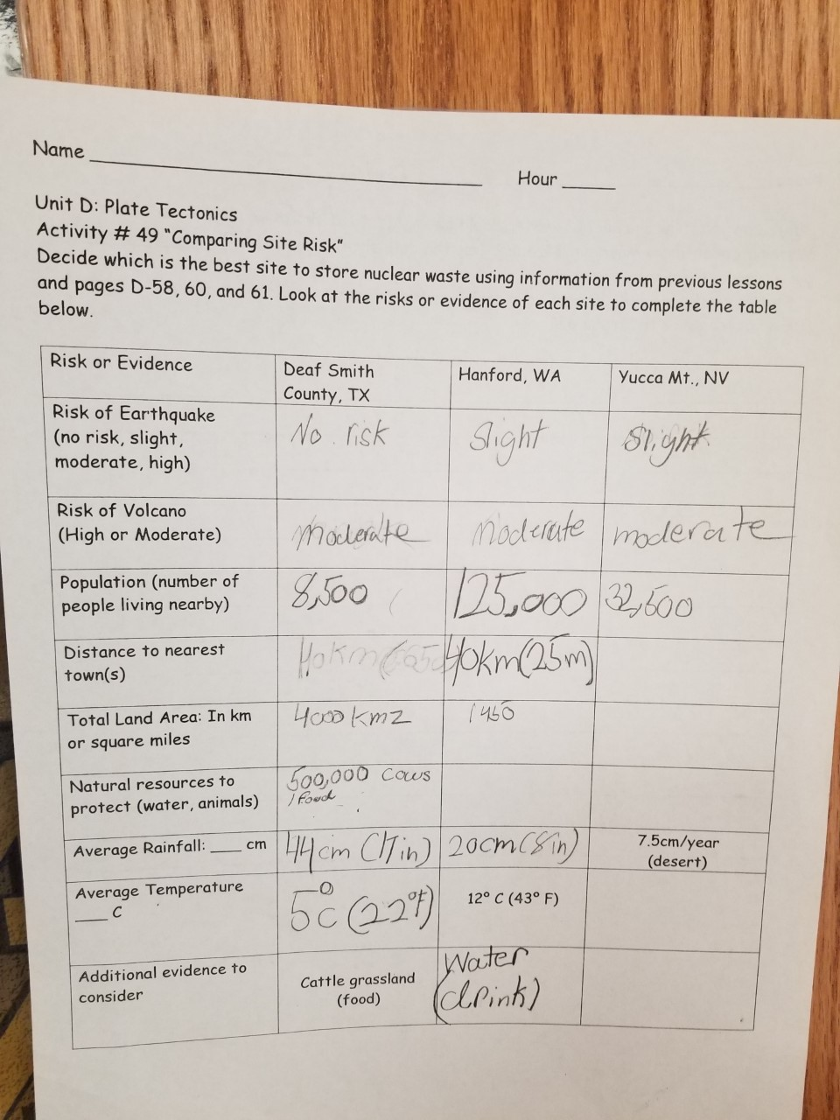

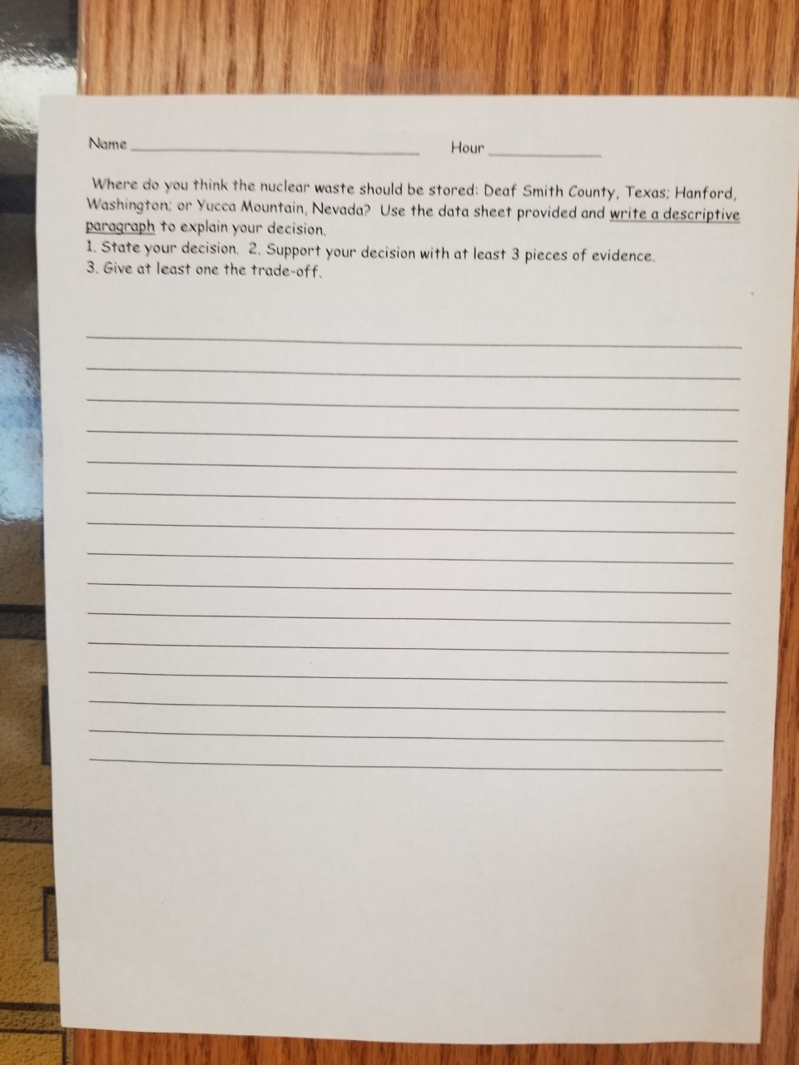

Week of  March 9- 12, 2020 | Lesson | Objective
Monday  Mar. 9 | Warm up:  Activity # 49 D-57 Compare risks for storing nuclear waste at 3 sites SS 49.1 | I can identify evidence that supports plate movement
Tuesday  Mar. 10 | Warm up: What occurs at a transform boundary? Look at your map and find a transform boundary.  - Complete Mapping Plate boundaries AQ. # 1-5 D-40 – 41  -Begin Activity # 45 Reading  - notes SS 45.1 | Same
Wednesday  Mar. 11 | Warm up: What is a convergent boundary? Give an example.  Field trip to movies hours 2-4  Hours 5-6 Study Notes for test | Same
Thursday  Mar. 12 | Warm up:  Research Earthquakes & Volcanoes  Hours 4-6
Friday  Mar. 13 | Warm up:  Complete Activity # 49  Descriptive Paragraph – Pick site for storing waste.  Note card study guide for Unit test Monday 3.16.20

Week of  March 2 - 6, 2020 | Lesson | Objective
Monday  Mar. 2 | Warm up: How does knowing about plate boundaries affect our decisions when storing nuclear waste?  Mapping Plate Boundaries  Activity # 44 D 37 - 41  Using Tables 1, 2 & 3 | I can identify evidence that supports plate movement
Tuesday  Mar. 3 | Warm up: What occurs at a transform boundary? Look at your map and find a transform boundary.  - Complete Mapping Plate boundaries AQ. # 1-5 D-40 – 41  -Begin Activity # 45 Reading  - notes SS 45.1 | Same
Wednesday  Mar. 4 | Warm up: What is a convergent boundary? Give an example.  Create a flipbook: Include the 3 plate boundaries drawing, label, definition & give an example from your map 44.2 | Same
Thursday  Mar. 5 | Warm up: What is a divergent boundary? Give an example.  Decision time: Activity # 49 Where will you store nuclear waste? D 57 – 61.
Friday  Mar. 6 | Warm up:  Graphing & Science World  ½ Day Hours 1 - 3

Week of  February 24-28 , 2020 | Lesson | Objective
Monday  Feb. 24 | Warm up: Write a paragraph describing one thing you did on winter break.  Pangea video clips + notes | I can identify evidence that supports plate movement
Tuesday  Feb. 25 | Warm up: What do you know about Pangea? Explain.  Zero: Chernobyl | Same
Wednesday  Feb. 26 | Warm up:  Snow Day
Thursday  Feb. 27 | Warm up:  Snow Day!
Friday  Feb. 28 | Warm up: What are two things you have learned about Chernobyl?  Complete video on Chernobyl, discussion and draw plate boundaries in science notebook. | I can identify the dangers of nuclear waste

Week of  February 10-14 , 2020 | Lesson | Objective
Monday  Feb. 10 | Warm up: Why are there such HUGE gaps on your timeline?  Geological Timeline with questions # 1- 7 | I can read earth’s timeline
Tuesday  Jan. 28 | Warm up: What do you know about Pangea? Explain.  Complete Geological Timeline | I can describe Pangea
Wednesday  Jan. 29 | Warm up: Quiz  Activity # 40 – “The Continents Movement – “Pangea”  SS 39.2 & 40.1
Thursday  Jan. 30 | Warm up: Why should we learn about water conservation?  Guest speakers from Michigan State University – “Water Conservation” | I will learn about the importance of conserving our water
Friday  Feb. 14 | Warm up:  Reading graphs  ½ Day Hours 4-6 | I can analyze data from a graph

Week of  February 3-7 , 2020 | Lesson | Objective
Monday  Feb. 3 | Warm up: What is the hottest layer of the earth?  Reading Act # 38  Beneath the “Earth’s Surface”.  Student Sheet # 38.2 draw layers of the earth, label: name, state (solid or liquid) temperature. Color | I can identify the layers of earth
Tuesday  Jan. 28 | Warm up: Draw a timeline of your life.  Complete the Earth drawing | Same
Wednesday  Jan. 29 | Warm up: How long have dinosaurs been extinct??  Geological Timeline Activity | I can create a timeline of earth
Thursday  Jan. 30 | Warm up: When were humans first on the earth?  Continue Geological Timeline | Same
Friday  Jan. 31 | Warm up:  Continue Geological Timeline | Same

Week of  January 27–30 , 2020 | Lesson | Objective
Monday  Jan. 27 | Warm up: List 2 reasons not to put nuclear waste in Yucca Mt.  Return Exit tickets  Research nuclear waste & earthquakes with questions | I can research for information
Tuesday  Jan. 28 | Warm up: Where is nuclear waste currently being stored in MI?  Complete research | Same
Wednesday  Jan. 29 | Warm up: What is plate tectonics?  Activity # 37 Volcano Lab | I will compare volcanic eruptions
Thursday  Jan. 30 | Warm up:  Complete Activity # 37  AQ # 1-3 - Collect | Same
Friday  Jan. 31 | Warm up:  Activity # 39 Beneath Earth’s Surface D-14 | I can draw the layers of earth accurately

Week of  January 13 -17, 2020 | Lesson | Objective
Monday  Jan. 13 | Warm up: How is Mohs Hardness scale used for identifying minerals? Include #s  Activity # 19 Rock Formation  AQ # 1-4 | I will be able to describe the process that forms various rock types
Tuesday  Jan. 14 | Warm up: Do we use color to identify minerals?  Complete Activity # 19, AQ, include # 4 on concept map | Same
Wednesday  Jan. 15 | Warm up: Is oil a mineral? Explain using organic and inorganic.  Activity # 20 Identifying Rock Types –Lab | Same
Thursday  Jan. 16 | Warm up: List 2 types of luster that is used in the mineral lab.  Complete Activity # 20 AQ # 1-4  Be sure to add words to concept map in your notebook from activity # 15 | Same
Friday  Jan. 17 | Warm up:  Add Mineral Fact sheets to science notebook. Prepare for quiz on Wednesday Jan. 22 | Same

Tuesday 1.21. 2020 Exit Ticket Activity # 22 Rock Cycle Game
Analysis Question: Where do rocks come from? Explain your answer using details and be sure to include how they are part of the rock cycle. Refer back to your concept map and SS 22.1. Use complete sentences and include all three rock types: igneous, metamorphic and sedimentary.
Friday 1.24.2020 Activity # 36 Exit Ticket
- Do you think nuclear waste should be stored at Yucca Mountain?
a.State your decision
b.Support your decision with as many pieces of evidence as you can.
c.Discuss the trade-offs of your decisio

Week of  January 6 -10, 2020 | Lesson | Objective
Monday  Jan. 6 | Warm up: What did you do on your vacation?  Activity # 15 Mineral Properties  Reading pg # 14 -19  Notes | I will be able to describe the process that forms various rock types
Tuesday  Jan. 7 | Warm up: List 3 properties of minerals.  Complete Activity # 15 AQ # 1-2  Video- Diamonds in Arkansas | Same
Wednesday  Jan. 8 | Warm up: Use your concept map to write a paragraph (Activity # 15)?  Activity # 16 Lab Mineral Identification  Create a notecard for mid-term | Same
Thursday  Jan. 9 | Warm up: Check Notecard for mid-term  Complete Activity # 16 | Same
Friday  Jan. 10 | Warm up:  Mid-term | Same

Week of  December 16 – 20, 2019 | Lesson | Objective
Monday  Dec. 16 | Warm up: What is deposition?  Rock Research Computer lab – Room 409 | I will investigate how the processes of weathering, erosion, and deposition have shaped earth’s surface
Tuesday  Dec. 17 | Warm up: Give 3 examples of weathering.  Rock Research Computer lab – Room 409 | Same
Wednesday  Dec. 18 | Warm up: How do we determine the age of rocks?  Activity # 14 Analyzing Data | Same
Thursday  Dec. 19 | Warm up:  Complete Activity # 14 and turn in questions | Same
Friday  Dec. 20 | Warm up:  Graphing & Earth Science Video  1/2 Day Hours 4-6 | Same

Week of  December 9-13 2019 | Lesson | Objective
Monday  Dec. 8 | Warm up: What is weathering?  Complete Crayon Rock Cycle Lab | I will investigate how the processes of weathering, erosion, and deposition have shaped earth’s surface
Tuesday  Dec. 10 | Warm up: What is erosion?  Rock Cycle worksheet in notebook & Reading | Same
Wednesday  Dec. 11 | Warm up: What are natural resources?  Lab – Activity 3 12Observing Natural Resources | Same
Thursday  Dec. 12 | Warm up: What is a mineral?  Lab - Activity # Diamond Dilemma, | Same
Friday  Dec. 13 | Warm up: Explain plate tectonics!  Complete Lab “Diamond Dilemma”  / Questions | Same

Week of  October  7 - 11 2019 | Lesson | Objective
Monday  Oct. 7 | Warm up: What are some of the obstacles that the engineers had to face in order to build in Dubai?  Finish video on Dubai+ taking notes  Begin designing leaf gliders with my team | I will use engineering skills to design a leaf glider
Tuesday  Oct. 8 | Warm up: What challenges have you encountered in your leaf design?  Continue working with your team to design leaf gliders and gather data on data sheet | Same
Wednesday Oct. 9 | Warm up: | Same
Thursday  Oct. 10 | Warm up:
Friday  Oct. 11 | Warm up:  ½ Day Hours 4,5&6

Week of  October  14 - 18 2019 | Lesson | Objective
Monday  Oct. 14 | Warm up: What are some of the obstacles that the engineers had to face in order to build in Dubai? | I will use engineering skills to design a leaf glider
Tuesday  Oct. 15 | Warm up: What challenges have you encountered in your leaf design? | Same
Wednesday Oct. 16 | Warm up: | Same
Thursday  Oct. 17 | Warm up:
Friday  Oct. 18 | Warm up:  ½ Day Hours 4,5&6

